What are scholarships? | A scholarship is an amount of money you are awarded to help pay for education/training that you do not have to pay back.  - Scholarships are considered “gift aid” and can come from many sources:  - Government (federal and/or state)  - Businesses and organizations  - Colleges, universities, training programs  - Community groups
- Scholarship myths vs. reality | - Not all scholarships are for grades or athletics  - Not all scholarships require essays  - If you win multiple small scholarships it adds up  - Scholarships are given based on other interest, talents, and academics
- Tips for making the scholarship process more efficient: | - Use scholarship search tools and college websites  - Read all scholarships instructions and rules  - Set aside time to search/apply for scholarships weekly  - Use a calendar or reminders for due dates  - Keep track of scholarships you are planning to apply for and if you apply  - Save all scholarship essays…they are often similar and can be revised/edited
- Log into Naviance |   Username: district ID#  Password: district password
- Use the Scholarship Search and National Scholarship Search tools in Naviance.  Click Colleges then find the section Scholarships & Money |   
- The National Scholarship Search tool in Naviance is a database where you add filters, and it will generate results for you to explore.  Click Colleges > National Scholarship Search to get started  (*Note: You can update filters at any time) | 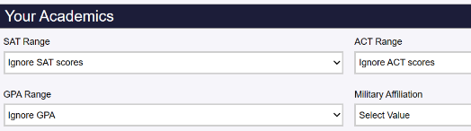  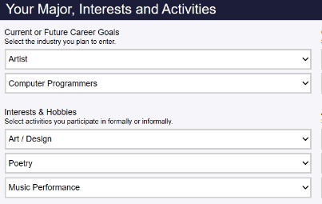  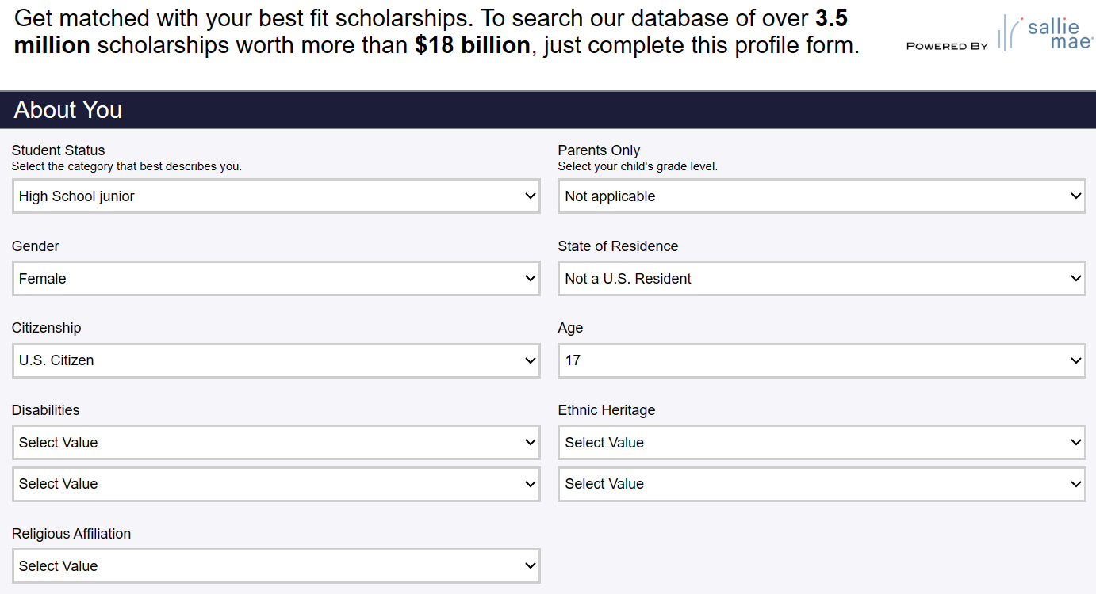
- Once you update your scholarship profile, review your matches.  Click the scholarship titles to find out more details and specifics. | 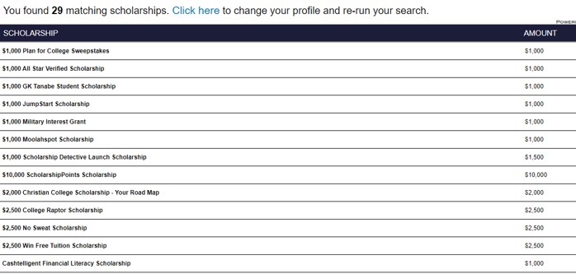
- The Scholarship Search provides you with a list of school specific, local, and regional scholarships.  Use Match and Filter to narrow your search.  (*Note: The list is manually updated, check it often) |   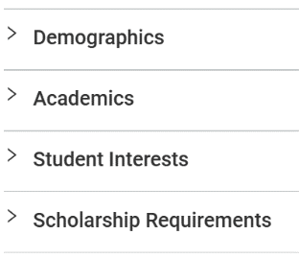
- To explore the details of the scholarship, click the title.  You will find either a link to a website or application download.  You can favorite scholarships to return to later in Naviance. |   
- Annual senior class scholarships! | - Each high school posts their own senior class scholarship in the Scholarship Search  - All seniors should fill out the application  - There are multiple scholarships within each senior class scholarship but only one application
- Identify scholarships you can apply to now and in the future.  Complete your senior class scholarship. | - Begin using the National Scholarship Search and Scholarship Search tools to make a list of potential scholarships.  - Apply to your own senior class scholarship  - Take a screenshot of your senior class scholarship application for your task completion upload.
- Task Completion: | Click on Planner>Tasks  Click the title of the task, Upload Documentation of Scholarship Application  Click Browse… to upload your scholarship documentation.

